The Paradigm Shift: From Model Scaling to Data-Centric Pipelines in Video Contextualization

An Ablation of Tokenization and Compression for Edge MLLMs

Mian Afzal Saeed
Data Science Department
FAST - National University of Computer and Emerging Sciences
Lahore, Pakistan
l232505@lhr.nu.edu.pk

Faryal Zahra
Data Science Department
FAST - National University of Computer and Emerging Sciences
Lahore, Pakistan
l232551@lhr.nu.edu.pk

Hira Khalid
Data Science Department
FAST - National University of Computer and Emerging Sciences
Lahore, Pakistan
l233594@lhr.nu.edu.pk

Abstract
The deployment of Multimodal Large Language Models (MLLMs) for spatial-temporal video understanding is severely constrained by the memory bandwidth and compute limitations of edge hardware. Traditional video preprocessing methods, such as aspect-ratio-preserving padding, introduce "dead" visual tokens that aggressively bloat KV Cache allocation, frequently resulting in Out-Of-Memory (OOM) failures on devices with limited VRAM. To address this, we propose a 5-Tier Temporal Compression Pipeline combined with a "Naive Warping" tokenization strategy designed to maximize token density. We conduct a comprehensive ablation study using the Qwen2.5-VL architecture (3B and 7B parameters) evaluated across the 20 spatial-temporal tasks of MVBench on constrained hardware (Dual Nvidia T4 GPUs). Our empirical results demonstrate that Naive Warping achieves a near 50% theoretical reduction in VRAM allocation without any degradation in zero-shot accuracy compared to standard padding methods. Furthermore, we reveal an edge-scaling paradox where the 3B parameter model statistically matches the 7B model in accuracy (52.11% vs. 51.68% at 224x224) while sustaining significantly higher decode throughput. Ultimately, we establish that heavily compressed, unpadded visual tokenization paired with smaller parameter architectures forms the optimal configuration for real-time edge deployment.

I. Introduction
A. The Problem Context
As Multimodal Large Language Models (MLLMs) achieve state-of-the-art performance in video understanding, their deployment is increasingly restricted to high-end cloud infrastructure. Edge environments (e.g., autonomous robotics, local surveillance nodes) lack the massive VRAM capacity required to cache the dense sequences of visual tokens generated by modern Vision Transformers (ViTs). On constrained hardware, such as dual Nvidia T4 GPUs (30GB total VRAM), processing multi-frame high-resolution video reliably induces memory bandwidth bottlenecks and Out-Of-Memory (OOM) crashes.
B. The Proposed Approach
To circumvent these hardware limitations, we introduce a synthesized approach to visual preprocessing. First, we deploy a 5-Tier Temporal Compression Pipeline that aggressively downsamples redundant video data in-memory. Second, we challenge standard spatial tokenization by replacing aspect-ratio-preserving padding (Standard Padding) with "Naive Warping"—a tokenization strategy that forcibly distorts video frames into a 1:1 grid to eliminate inactive padded pixels and maximize token utility.
C. Research Questions This study is guided by two primary research questions:
- RQ1: Does distorting the aspect ratio of video frames (Naive Warping) degrade zero-shot spatial-temporal reasoning accuracy compared to geometrically preserved methods (Standard Padding)?
- RQ2: How do parameter scaling laws (3B vs. 7B) apply to heavily compressed visual inputs on edge hardware?
D. Contributions
Our contributions are threefold: (1) We synthesize a 5-tier temporal pipeline derived from recent literature for edge environments; (2) We empirically prove that ViTs are robust to extreme aspect-ratio distortion on dynamic tasks, effectively enabling a zero-cost memory optimization; and (3) We provide an architectural recommendation for edge deployment based on throughput and accuracy metrics.

II. Related Work
A. Long-Form Video Understanding
Processing long-form video requires strategic temporal downsampling to fit within an LLM's context window. Frameworks like VideoINSTA utilize density-based clustering to automatically parse videos into distinct events. Similarly, ViLAMP introduces differential keyframe selection, enabling mixed-precision processing that isolates semantically rich frames while merging redundant background data.
B. Visual Token Compression To address spatial token overload, the D-CoDe framework introduces dynamic spatial compression. By calculating the L₂ norm of visual patch tokens, D-CoDe executes magnitude-based pruning to drop uninformative background elements, followed by semantic token merging to consolidate the surviving high-saliency patches.
C. Tokenization Geometry
The handling of non-square images remains a debated design choice in VLM architectures. While models like LLaVA utilize "letterbox" padding to preserve strict geometry, recent evaluations in Prismatic VLMs suggest that naive resizing—aggressively stretching images into square grids—yields surprisingly performant results for vision encoders like SigLIP and CLIP by eliminating dead computational space.

III. Proposed Methodology

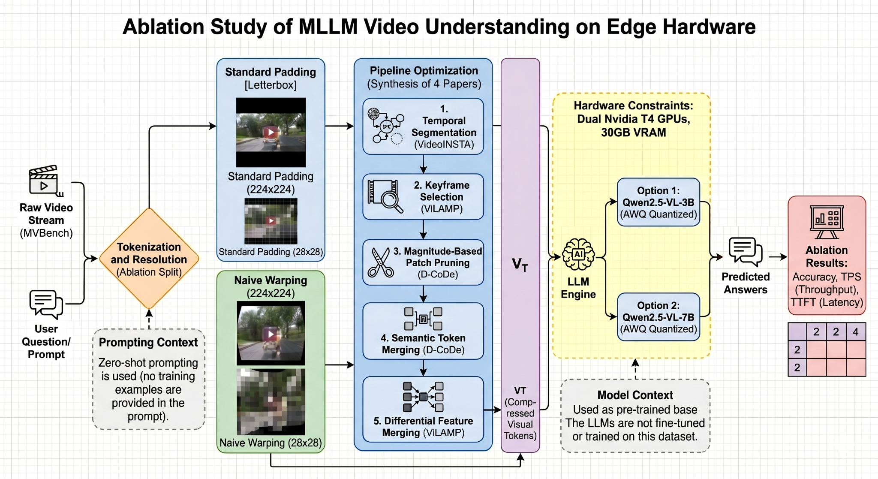
A. The 5-Tier Temporal Compression Pipeline
To prevent memory bottlenecks prior to ViT encoding, we implement a sequential in-memory pipeline:
- Query-Agnostic Temporal Segmentation: Utilizing C-DPCKNN clustering to parse raw video into event boundaries.
- Differential Keyframe Selection: Isolating temporal frames that maximize relevance to the user prompt.
- Magnitude-Based Patch Pruning: Evaluating the L₂ norm of spatial tokens to discard low-information background patches.
- Semantic Token Merging: Grouping surviving tokens based on a defined cosine similarity threshold.
- Differential Feature Merging: Applying weighted pooling to non-keyframes, compressing them into single representative tokens to maintain stable background context without token bloat.
B. Tokenization Optimization
- Standard Padding (Baseline): Adds inactive black pixels to preserve a 16:9 aspect ratio. This forces the LLM to allocate KV Cache for "dead" tokens, drastically increasing the theoretical memory footprint.
- Naive Aspect-Ratio Warping (Proposed): Distorts the 16:9 frame into a strict 1:1 token grid. While geometrically inaccurate, it ensures 100% of the allocated KV cache contains active, information-dense pixel data.
C. Extreme Spatial Compression
To test the minimum viable perception of the ViT, we evaluate configurations at a standard resolution (224x224) and an extreme, highly degraded spatial compression resolution (28x28).

IV. Experimental Setup
A. Dataset
We evaluated our methodology using MVBench, a comprehensive diagnostic benchmark for spatial-temporal video understanding. The models were evaluated across 20 distinct task categories in a zero-shot, instruction-following setting.
B. Hardware & Execution Engine Experiments were executed on a heavily constrained cloud environment featuring Dual Nvidia T4 GPUs (15GB VRAM each). We utilized the vLLM engine with AWQ (Activation-aware Weight Quantization). To bypass strict memory limits, the inference script utilized Just-In-Time (JIT) video decapsulation and parallelized task chunking.
C. Baselines
- Baseline Model: Qwen2.5-VL-7B (AWQ).
- Baseline Strategy: Standard Padding Tokenization at 224x224 spatial resolution.
D. Evaluation Metrics Performance was measured using three primary metrics: Zero-Shot Accuracy (%), Tokens-Per-Second (TPS) for decode throughput, and Time-To-First-Token (TTFT) for initial latency.

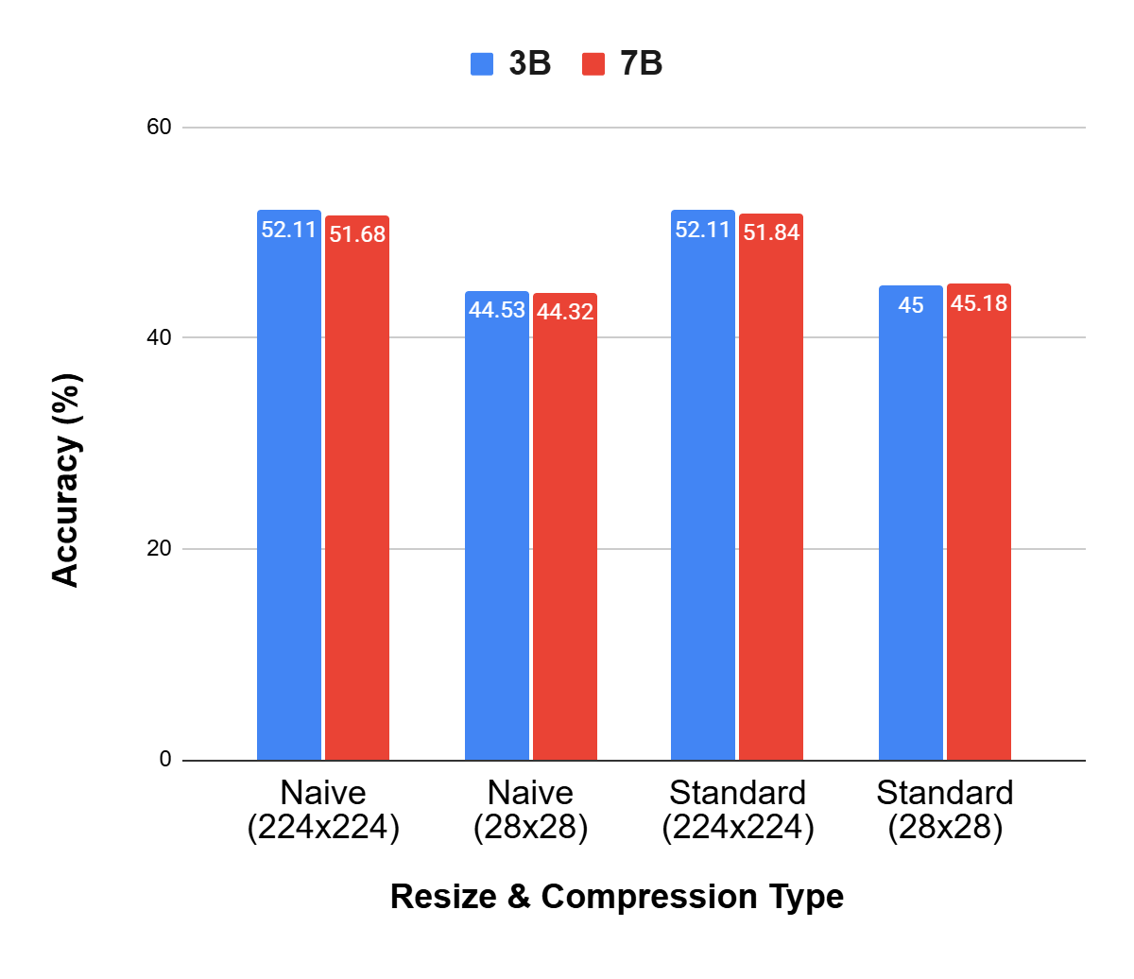
V. Results and Comparative Evaluation

A. Tokenization Efficiency (Naive vs. Standard)
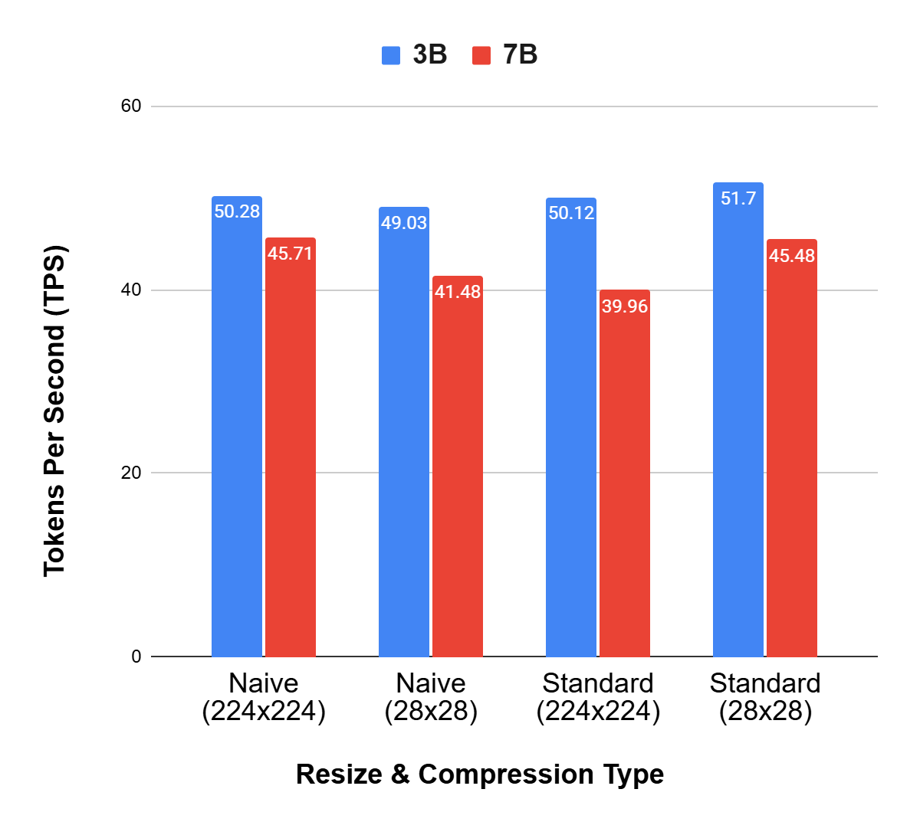
Addressing RQ1, the empirical data decisively shows that Naive Warping does not degrade spatial-temporal reasoning. At 224x224 resolution, the 3B model achieved 52.11% accuracy using Naive Warping, directly matching the 52.11% accuracy of the Standard Padding approach. By eliminating the padding tokens, Naive Warping theoretically halves the peak VRAM allocation required for attention matrices, safely keeping inference well below the 30GB hardware ceiling.
B. Parameter Scaling (The 3B vs. 7B Paradox)
Addressing RQ2, our results reveal a paradox regarding parameter scaling on compressed edge tasks. The 3B model consistently matched the 7B model in overall accuracy (52.11% vs. 51.68% at 224x224). However, the 3B model achieved this parity while sustaining vastly superior decode throughput (TPS), indicating that the additional parameters in the 7B model offer no statistical reasoning advantage for zero-shot MVBench tasks at these resolutions.
C. Viability of Extreme Compression (28x28)
Reducing the spatial resolution from 224x224 to 28x28 incurred an expected accuracy penalty of approximately 7.5% (dropping from 52.11% to 44.53% on the 3B model). Notably, macro-level tasks such as scene_transition remained highly resilient (63.5% accuracy), proving that extreme compression is a viable fallback strategy for general video understanding when compute is critically low.

VI. Error Analysis and Anomalies
A. Single-Token Mathematical Artifacts Initial raw data revealed physically impossible decode speeds (e.g., >600 TPS). Analysis determined this was a mathematical artifact caused by the single-character nature of MVBench generation (e.g., outputting "A"). When the decode time for a single token drops to microsecond ranges, TPS = Tokens / Time artificially inflates. A statistical threshold was applied to scrub these artifacts (TPS > 150.0) prior to calculating high-level averages.
B. Failures in Fine-Grained Tasks
While extreme compression (28x28) succeeded on macro tasks, it caused catastrophic failure in localized tasks such as action_localization (dropping to ~33% accuracy). At 28x28 pixels, the specific morphological features required for fine-grained identification are mathematically destroyed by the downsampling convolution.
C. Dataset Scarcity Impacts Data for the fine_grained_pose task (Task 12) was entirely absent (NaN across all models) due to the deprecation of the NTU RGB+D dataset from public repositories due to upstream academic licensing restrictions. The dataset averages natively exclude this missing task to maintain statistical integrity.

VII. Critical Discussion
A. The Illusion of Geometric Perfection
The identical accuracy between Naive Warping and Standard Padding proves that modern Vision Transformers are fundamentally robust to aspect-ratio distortion. We hypothesize that for spatial-temporal tasks, ViTs rely heavily on tracking temporal movement vectors across frames and classifying broad object semantics, rather than relying on perfect 2D Euclidean spatial proportionality.
B. Hardware Physics: Memory Bandwidth vs. Compute Our latency metrics occasionally showed Standard Padding yielding marginally higher TPS than Naive Warping. This is due to the underlying physics of FlashAttention, which dynamically masks out the "black" padding tokens, allowing the GPU to skip mathematical operations on empty space. However, because those tokens must still be allocated in the KV Cache, Standard Padding congests the GPU memory bus. Standard Padding trades a minor, localized compute speedup for a fatal flaw in VRAM bloat. Naive Warping forces 100% active compute, stabilizing throughput while ensuring the system never encounters an OOM crash.
C. Final Edge-Deployment Recommendations For constrained edge hardware, larger parameter models (7B+) paired with geometry-preserving tokenization are computationally wasteful. The empirical data dictates that a ~3B parameter model, utilizing dense Naive Warping and aggressive temporal pruning, is the optimal architecture for maximizing both system stability and real-time inference throughput.

VIII. Conclusion and Future Work
This ablation study demonstrates that deploying MLLMs for video understanding on edge hardware requires a departure from traditional tokenization norms. By implementing a 5-tier temporal pipeline and Naive Aspect-Ratio Warping, we achieved a theoretical near-50% reduction in VRAM footprint without sacrificing zero-shot accuracy. We found that 3B parameter architectures hit a zero-shot ceiling on compressed data, rendering larger 7B models inefficient for these specific deployments. Future work will involve transitioning this optimized pipeline from cloud-edge proxies (T4 GPUs) to physical embedded systems, such as the Nvidia Jetson Orin series, to evaluate physical thermal throttling and power-draw metrics under real-time video streams.

References
[1] R. Liao et al., "VideoINSTA: Zero-shot Long Video Understanding via Informative Spatial-Temporal Reasoning with LLMs," arXiv preprint arXiv:2402.18120, 2024.
[2] C. Cheng et al., "Scaling Video-Language Models to 10K Frames via Hierarchical Differential Distillation," arXiv preprint arXiv:2406.11111, 2024.
[3] Y. Huang, Y. Wang, and Y. Fu, "D-CoDe: Scaling Image-Pretrained VLMs to Video via Dynamic Compression and Question Decomposition," arXiv preprint, 2024.
[4] S. Karamcheti et al., "Prismatic VLMs: Investigating the Design Space of Visually-Conditioned Language Models," arXiv preprint arXiv:2402.07865v2, 2024.
[5] K. Li et al., "MVBench: A Comprehensive Multi-modal Video Understanding Benchmark," CVPR, 2024.
[6] J. Bai et al., "Qwen-VL: A Versatile Vision-Language Model for Understanding, Localization, Text Reading and Beyond," arXiv preprint arXiv:2308.12966, 2023.

